**World Buskers**

As a tourist, the best way to experience this is through the amazing festivals that the country holds during different times of the year. While some give you a glimpse of the Māori culture, some let you enjoy the amazing food and others focus solely on the various cultural art forms of not just New Zealand but also the world. There are certain festivals for party lovers as well that focus on modern music styles including alternative, rock, punk and electronic music genres.

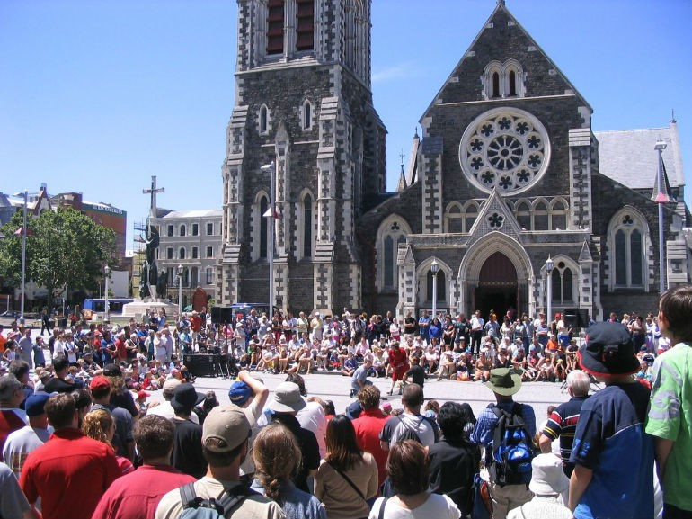

World Buskers Festival is a unique festival in many ways because of the concept behind it. You get to witness some of the best busking pitches from around the world perform here at Christchurch. Musicians, visual artists, magicians, dancers, contortionists, comedians and various other artists perform here. This makes it a festival where you can enjoy multiple genres of performances on a single stage. It is generally held between January 10 and February 3.